Running Gradle Builds

Gradle Core Concepts

* Invoke tasks
* Turn on features
* Apply plugins
* Add dependencies

Gradle Overview

* Gradle automates building, testing, and deployment of software from information in build scripts

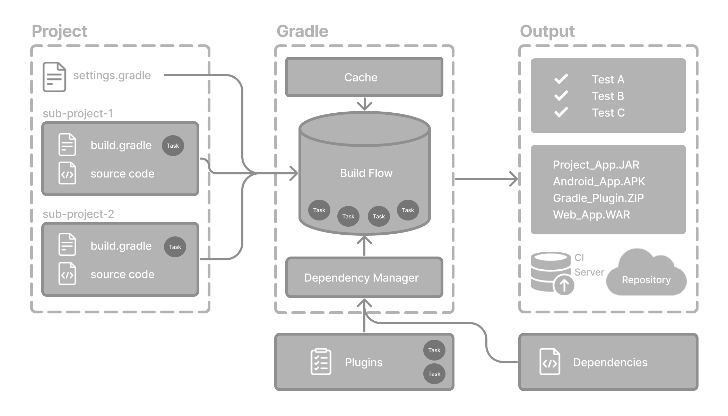

What is a gradle project? – it is a piece of software that can be built, such as an application.

Single project – this is a single project build and the single project is called a root project.

Multi-project builds – this has 1 root project, and any number of subprojects to be built

What is a build script? – build scripts tell gradle what steps to take to build the project

Each project can have one or more build scripts

What is dependency management? - this is an automated technique for declaring and resolving external resources that the project will need

Each gradle project will include a number of external dependencies that Gradle will resolve while executing the tasks to do the build.

What are Tasks? -

Tasks are the basic units of work – examples – running test, compiling code.

Each gradle project has a build script – inside the build script there are tasks.

What are plugins ? - plugins can optionally contribute tasks to a project!

What does the gradle project structure look like ?

project

├── gradle

│ ├── libs.versions.toml

│ └── wrapper

│ ├── gradle-wrapper.jar

│ └── gradle-wrapper.properties

├── gradlew

├── gradlew.bat

├── settings.gradle(.kts)

├── subproject-a

│ ├── build.gradle(.kts)

│ └── src

└── subproject-b

├── build.gradle(.kts)

└── src

1. In the project, there is a folder called “gradle”

This folder typically stores wrapper jar files

This folder typically stores a .toml file – this is for dependency management

1. In the project, in its root, there is usually a gradlew and gradlew.bat 🡪 these are gradle wrapper scripts – which interact with the jar
2. In the project, in its root, there is usually a settings.gradle file 🡪 this defines a root project and its subprojects
3. In the project, in its root, there is a subproject-a folder, which contains the SRC and the build.gradle in the same level 🡪 the build.gradle is the build script , the SRC is the source code of the project.

How to invoke gradle?

Invoke means to cause something to be carried out

So how to cause gradle to be carried out ?

There are 2 ways.

1. To use the installed version of gradle,

Type in command “Gradle build”

1. To use the gradle wrapper

This is a script that will invoke a declared version of gradle.

Type in command “gradlew build” or “gradlew.bat build”